“Intelligent AI-Based Smart Dairy Farm Management System”

CO-1 ASSESSMENT TOOL-1
CASE STUDY ANALYSIS REPORT
Submitted in the partial fulfilment for the course of
CSA1017 - SOFTWARE ENGINEERING
to the award of the degree of
BACHELOR OF ENGINEERING
IN
COMPUTER SCIENCE AND ENGINEERING
Submitted by
R KALAI AMUDHAN(192511292)
Under the Supervision of
Dr. LATHA R


SIMATS ENGINEERING
Saveetha Institute of Medical and Technical
Sciences Chennai-602 105
July 2026

TABLE OF CONTENTS:-
S. No. | Contents | Page No.
1 | Introduction | 4
2 | Understanding the Problem Statement | 4
2.1 | Problem Explanation | 5
2.2 | Objectives of the Proposed System | 5
2.3 | Scope of the Problem | 4
3 | Stakeholder and Challenge Analysis | 6
3.1 | Stakeholders | 6
3.2 | Roles and Responsibilities | 7
3.3 | Challenges Faced by Stakeholders | 8
4 | Current System Analysis | 8
4.1 | Existing System | 8
4.2 | Strengths of the Existing System | 8
4.3 | Limitations of the Existing System | 9
4.4 | Problems and Gaps | 9
5 | Proposed Software Solution | 10
5.1 | Proposed System | 10
5.2 | Functional Modules | 10
5.3 | Functional Requirements | 11
5.4 | Non-Functional Requirements | 12
5.5 | Application of Software Engineering Principles | 12
6 | Methodology / Framework Justification | 13
6.1 | Selected SDLC Model – Agile (Scrum) | 13
6.2 | Why Agile is Suitable | 14
6.3 | Agile Development Life Cycle | 14
6.4 | Scrum Roles | 15
6.5 | Scrum Artifacts | 16
6.6 | Benefits of Agile for the Proposed System | 16
6.7 | How Agile Supports Software Engineering Principles | 17
7 | Expected Outcomes and Limitations | 18
7.1 | Expected Outcomes | 18
7.2 | How the Proposed Solution Addresses Existing Challenges | 18
7.3 | Risks and Limitations | 19
7.4 | Future Enhancements | 19
8 | Conclusion | 19

1. Introduction
The dairy industry plays a significant role in agriculture by supplying milk and dairy products to consumers. Modern dairy farms require efficient monitoring of cattle health, feeding schedules, milk production, and environmental conditions to maximize productivity. However, many farms still depend on manual observation, which is time-consuming and prone to errors.

Advancements in Artificial Intelligence (AI), Internet of Things (IoT), wearable sensors, cloud computing, and data analytics have transformed traditional farming into smart farming. These technologies enable continuous monitoring of livestock, early disease prediction, optimized feeding schedules, automated record management, and real-time decision-making.
The Intelligent AI-Based Smart Dairy Farm Management System is designed to improve dairy farm operations by integrating AI and IoT technologies. The system continuously monitors cattle health, predicts diseases, tracks milk production, provides feeding recommendations, and generates analytical reports, ultimately improving animal welfare and increasing dairy productivity.
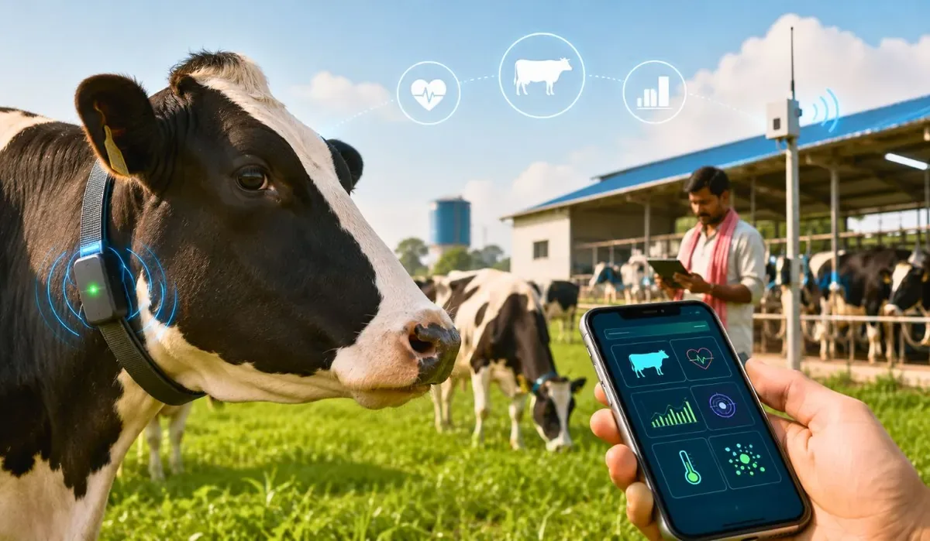

2. Understanding the Problem Statement
2.1 Problem Explanation
Traditional dairy farm management mainly depends on manual observation by farmers. Monitoring cattle health, maintaining feeding schedules, recording milk production, and identifying diseases manually consume considerable time and effort. Since diseases are often detected only after visible symptoms appear, delayed treatment may reduce milk production and negatively impact animal health.
The proposed AI-Based Smart Dairy Farm Management System addresses these issues by using wearable sensors, AI algorithms, cloud computing, and IoT technology. The system continuously monitors cattle health, predicts diseases at an early stage, optimizes feeding schedules, tracks milk production, and provides real-time analytics to improve overall farm management.
2.2 Objectives of the Proposed System
The objectives of the proposed system are:
- Monitor cattle health continuously using wearable sensors.
- Predict livestock diseases using Artificial Intelligence.
- Optimize feeding schedules based on cattle health.
- Track milk production accurately.
- Generate farm performance reports.
- Improve livestock welfare.
- Reduce operational costs.
- Enhance dairy productivity and profitability.

2.3 Scope of the Problem
The proposed system includes the following functionalities:
- Continuous cattle health monitoring
- AI-based disease prediction
- Smart feeding management
- Milk production monitoring
- Environmental condition monitoring
- Cloud-based data storage
- Mobile and web applications
- Farm performance analytics
- Automated notifications and alerts
The system is suitable for small, medium, and large-scale dairy farms.

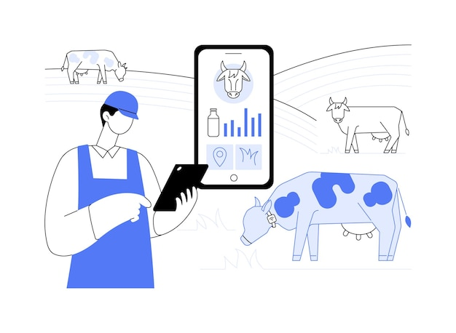

3. Stakeholder and Challenge Analysis
3.1 Stakeholders
The major stakeholders involved in the system include:
Stakeholder | Role
Farmers | Manage livestock and daily farm activities
Farm Managers | Supervise farm operations and productivity
Veterinarians | Monitor cattle health and provide treatment
Dairy Workers | Perform feeding, milking, and maintenance
Dairy Companies | Collect and process milk
System Administrator | Maintain software and cloud infrastructure
Government Agencies | Monitor compliance with livestock regulations

3.2 Roles and Responsibilities
Farmers
- Monitor cattle health
- Receive alerts
- Make farm management decisions
Farm Managers
- Monitor production
- Manage workers
- Analyze farm reports
Veterinarians
- Diagnose diseases
- Review AI predictions
- Recommend treatments
Dairy Workers
- Feed cattle
- Record farm activities
- Maintain cleanliness
Dairy Companies
- Monitor milk quality
- Purchase milkSystem Administrator
- Maintain servers
- Update software
- Ensure cybersecurity

3.3 Challenges Faced by Stakeholders
The existing dairy farming system faces several challenges:
- Delayed disease detection
- Manual health monitoring
- High labor costs
- Human errors in record keeping
- Poor feeding optimization
- Lack of real-time information
- Difficulty managing large farms
- Low operational efficiency
4. Current System Analysis

4.1 Existing System
Currently, most dairy farms rely on manual observation and paper-based record management. Farmers inspect cattle physically, maintain feeding schedules manually, and record milk production in notebooks or spreadsheets. Veterinary consultation usually occurs only after animals show visible symptoms of illness.

4.2 Strengths of the Existing System
- Easy to understand
- Low implementation cost
- No advanced technical knowledge required
- Suitable for very small farms

4.3 Limitations of the Existing System
- Time-consuming
- High dependency on manual labor
- Delayed disease identification
- Inaccurate record management
- No predictive analysis
- Poor decision-making support
- Increased operational expenses
4.4 Problems and Gaps
The existing system lacks:
- Continuous health monitoring
- AI-based disease prediction
- Smart feeding recommendations
- Automated report generation
- Centralized cloud database
- Real-time analytics
- Remote monitoring capabilities
These gaps reduce productivity and affect livestock welfare. 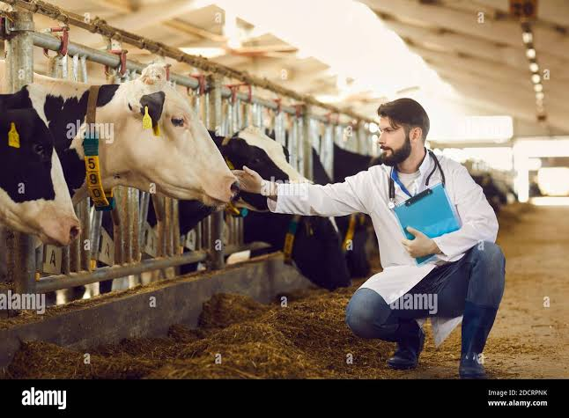
5. Proposed Software Solution
5.1 Proposed System
The proposed Intelligent AI-Based Smart Dairy Farm Management System integrates Artificial Intelligence, IoT, cloud computing, wearable sensors, and data analytics into a single software platform.
The system continuously collects cattle health data through wearable sensors and environmental sensors. AI algorithms analyze this information to predict diseases, recommend feeding schedules, monitor milk production, and generate analytical reports that assist farmers in making better decisions.

5.2 Functional Modules
Module 1: User Management
- User Registration
- Login Authentication
- Role Management
- Farmer Profile
Module 2: Cattle Health Monitoring
- Temperature Monitoring
- Heart Rate Monitoring
- Activity Tracking
- Health Alerts
Module 3: AI Disease Prediction
- Disease Detection
- Risk Prediction
- Veterinary Recommendations
- Early Warning Notifications

Module 4: Smart Feeding Management
- Feeding Schedule
- Nutrition Planning
- Feed Quantity Optimization
- Feeding Alerts
Module 5: Milk Production Monitoring
- Daily Milk Collection
- Production History
- Milk Quality Analysis
- Productivity Reports
Module 6: Farm Analytics Dashboard
- Health Reports
- Production Reports
- Cost Analysis
- Performance Graphs
- Real-Time Dashboard

5.3 Functional Requirements
The system shall:
- Register and authenticate users.
- Monitor cattle health continuously.
- Predict diseases using AI.
- Track milk production.
- Manage feeding schedules.
- Generate reports.
- Send notifications and alerts.
- Store farm records securely.
5.4 Non-Functional Requirements
Requirement | Description
Performance | Fast response time
Reliability | High system availability
Scalability | Supports large farms
Security | Authentication and encryption
Usability | Easy-to-use interface
Maintainability | Easy software maintenance
Availability | 24×7 cloud access

5.5 Application of Software Engineering Principles
Modularity
The system is divided into independent modules such as health monitoring, disease prediction, feeding management, milk tracking, and reporting, making development and maintenance easier.
Scalability
Cloud infrastructure allows the system to support an increasing number of cattle and multiple farms without reducing performance.
Maintainability
The modular architecture enables developers to update or modify individual modules without affecting the entire system.
Reliability
Continuous monitoring, cloud backup, and automated alerts ensure consistent and dependable system performance.
Usability
A simple web and mobile interface allows farmers with limited technical knowledge to operate the system effectively.
Security
The system provides secure login, role-based access control, encrypted data storage, and secure cloud communication to protect sensitive farm information.

6. Methodology / Framework Justification
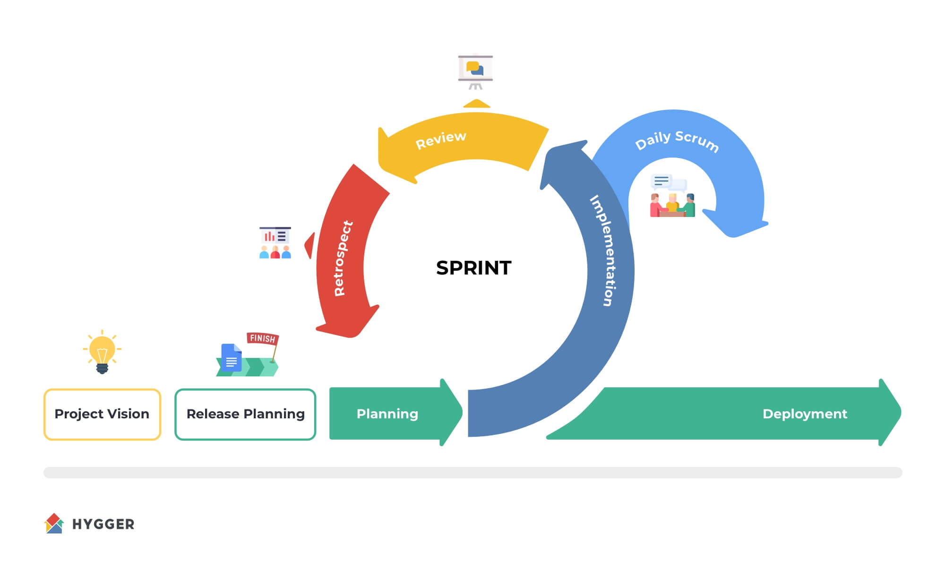
6.1 Selected SDLC Model: Agile (Scrum)
The Agile (Scrum) Software Development Life Cycle (SDLC) model is selected for developing the Intelligent AI-Based Smart Dairy Farm Management System. Since the system integrates multiple technologies such as Artificial Intelligence (AI), Internet of Things (IoT), wearable sensors, cloud computing, and data analytics, it requires continuous development, testing, and improvement. Agile supports iterative development, allowing the project team to deliver software in small increments while continuously incorporating stakeholder feedback.

6.2 Why Agile is Suitable
Agile is the most suitable methodology because:
- It allows frequent interaction with farmers, veterinarians, and farm managers to gather continuous feedback.
- New features such as AI models, additional sensors, or reporting modules can be added without redesigning the entire system.
- Software is delivered in small working versions (sprints), making testing easier.
- Continuous testing helps identify and fix bugs at an early stage.
- It reduces development risks through regular reviews and feedback.
- It improves collaboration among developers, AI engineers, IoT specialists, testers, and stakeholders.
- The methodology is flexible enough to accommodate changing farm requirements and technological advancements.

6.3 Agile Development Life Cycle
The proposed system follows these Agile phases:
- Requirement Gathering
  - Collect requirements from dairy farmers, veterinarians, and farm managers.
  - Analyze farm operations and identify system requirements.
- Sprint Planning
  - Divide the project into small development iterations (sprints).
  - Prioritize important features.
- System Design
  - Design system architecture.
  - Create database schema, UI mockups, and IoT integration plans.
- Development
  - Develop modules independently.
  - Integrate AI models, IoT devices, and cloud services.
- Testing
  - Perform unit testing, integration testing, system testing, and user acceptance testing.
  - Verify AI prediction accuracy and sensor functionality.
- Deployment
  - Deploy the application on cloud servers.
  - Configure IoT devices and user accounts.
- Maintenance
  - Fix bugs.
  - Improve AI models.
  - Add new features and update the system regularly.

6.4 Scrum Roles
The Scrum framework consists of the following roles:
Role | Responsibility
Product Owner | Defines project requirements and prioritizes features
Scrum Master | Ensures Agile practices are followed and removes project obstacles
Development Team | Designs, develops, tests, and deploys the software
Stakeholders | Provide feedback and validate system functionality

6.5 Scrum Artifacts
The important Scrum artifacts include:
- Product Backlog
- Sprint Backlog
- Increment
- Sprint Review
- Sprint Retrospective
These artifacts help organize project tasks and ensure continuous improvement.

6.6 Benefits of Agile for the Proposed System
The Agile methodology provides several benefits:
- Faster software delivery.
- Improved software quality.
- Better customer satisfaction.
- Continuous stakeholder involvement.
- Easy adaptation to changing requirements.
- Early identification of technical issues.
- Reduced project risks.
- Improved teamwork and communication.
- Easier integration of new AI algorithms and IoT devices.
- Continuous system enhancement after deployment.

6.7 How Agile Supports Software Engineering Principles
Software Engineering Principle | Agile Support
Modularity | Develops each module independently
Scalability | Supports adding new modules and farms
Maintainability | Frequent updates and easy bug fixing
Reliability | Continuous testing improves reliability
Security | Regular security updates and vulnerability fixes
Usability | User feedback improves interface design

7. Expected Outcomes and Limitations
7.1 Expected Outcomes
The proposed system is expected to achieve the following:
- Improved livestock health
- Early disease prediction
- Increased milk production
- Optimized feeding schedules
- Better farm management
- Reduced operational costs
- Enhanced animal welfare
- Data-driven decision making

7.2 How the Proposed Solution Addresses Existing Challenges
Existing Challenge | Proposed Solution
Manual health monitoring | IoT wearable sensors
Delayed disease detection | AI disease prediction
Manual feeding | Smart feeding management
Poor record keeping | Cloud database
Lack of analytics | AI dashboard
Human errors | Automation
Low productivity | Real-time monitoring

7.3 Risks and Limitations
Although the proposed system offers several benefits, certain limitations exist:
- High initial implementation cost
- Dependence on internet connectivity
- Regular sensor maintenance required
- AI prediction accuracy depends on training data
- Farmers require technical training
- Cybersecurity threats
- Hardware failures may affect monitoring

7.4 Future Enhancements
Future versions of the system may include:
- Computer vision for cattle behavior analysis
- Drone-based farm surveillance
- Blockchain for milk traceability
- AI-powered veterinary chatbot
- Robotic milking systems
- Weather forecasting integration
- Voice assistant support
- Multi-language mobile application

8. Conclusion
The Intelligent AI-Based Smart Dairy Farm Management System presents a modern and intelligent solution to the challenges faced by traditional dairy farms. By integrating Artificial Intelligence (AI), Internet of Things (IoT), wearable sensors, cloud computing, and real-time analytics, the system enables farmers to monitor cattle health continuously, predict diseases early, optimize feeding schedules, and efficiently track milk production.
Unlike conventional dairy farm management, which relies on manual observation and paper-based records, the proposed system automates critical farm operations and provides accurate, data-driven insights that support better decision-making. This leads to improved livestock health, increased milk yield, reduced disease outbreaks, enhanced animal welfare, and significant reductions in operational costs.
The application of software engineering principles such as modularity, scalability, maintainability, reliability, usability, and security ensures that the system is robust, flexible, and capable of supporting future technological advancements. The adoption of the Agile (Scrum) methodology further enables iterative development, continuous stakeholder feedback, efficient testing, and simplified maintenance, ensuring that the system remains adaptable to evolving farm requirements.
Moreover, the proposed solution contributes to the broader vision of smart agriculture and precision livestock farming by leveraging advanced technologies to improve farm efficiency and sustainability. It supports environmentally responsible farming practices by optimizing resource utilization, reducing feed wastage, and enabling proactive animal healthcare.
Although the system involves challenges such as initial implementation costs, IoT infrastructure requirements, internet dependency, and periodic sensor maintenance, its long-term benefits significantly outweigh these limitations. Future enhancements, including computer vision, drone surveillance, blockchain-based milk traceability, robotic milking systems, and AI-powered veterinary assistance, can further strengthen the platform and make it a comprehensive smart farming ecosystem.
agricultural practices.
In conclusion, the Intelligent AI-Based Smart Dairy Farm Management System is a practical, scalable, and future-ready software solution that transforms traditional dairy farming into an intelligent, automated, and data-driven process. By improving productivity, profitability, and livestock welfare, the proposed system has the potential to contribute significantly to the sustainable growth of the dairy industry and modern agricultural practices.

